## Artificial

## Intelligence and Machine Learning

Project Report

Semester-IV (Batch-2022)

Ad Prediction Model

**Supervised By: Submitted By:**

Mohd. Talib Rohan Kumar, 2210990740 (G-5)

Ravinder Singh, 2210990719 (G-5)

Rajiv pal, 2210990709 (G-5)

Rishi Chaudhary, 2210990726 (G-5)

**Department of Computer Science and Engineering**

## Chitkara University Institute of Engineering & Technology,

## Chitkara University, Punjab

**Table Of Contents**

|  |  |  |
| --- | --- | --- |
| Sr.no | Section | Page No |
| 1. | Introduction  1.1 Background  1.2 Objectives  1.3 Significance | 3-5 |
| 2. | Problem Definition and Requirements  2.1 Problem Statement | 6 |
| 3. | Proposed Design/Methodology:  3.1 Technical Details  3.2 File Structure | 7-8 |
| 4. | Result  4.1 Screenshots of Output  4.2 Screenshots of Code | 9-12 |
| 5. | References | 13 |

**1. Introduction:**

In the vast landscape of digital marketing, the ability to target the right audience with precision has become crucial for businesses aiming to maximize their advertising effectiveness. One of the key elements in achieving this precision is the prediction of user behavior, particularly whether a user will click on an advertisement. This project delves into the realm of ad click prediction, leveraging machine learning techniques to unravel the mysteries behind user engagement with online ads.

Imagine you're running an online store specializing in handmade jewelry. You invest a significant portion of your marketing budget in flashy banner ads displayed across various websites. However, are these ads reaching the intended audience? Are users actually clicking on them and visiting your store? This is where the magic of ad click prediction comes into play.

Think of ad click prediction as having a secret weapon in your digital marketing arsenal. By accurately forecasting whether a user will click on your ad, you can tailor your marketing efforts to target those most likely to be interested in your products or services. No longer do you need to cast a wide net and hope for the best; instead, you can deliver your message directly to those who are most receptive to it.

This project aims to tackle the challenge of ad click prediction head-on. By analyzing a plethora of user attributes and past interaction data, we seek to develop a machine learning model that acts as a "click whisperer," predicting with precision whether a user will engage with an advertisement. By understanding the underlying factors that drive user clicks, businesses can optimize their advertising campaigns, stretch their marketing budgets further, and ultimately convert clicks into sales.

* 1. **Background:**

In today's digital age, online advertising has become a cornerstone of marketing strategies for businesses across industries. According to Statista, global digital ad spending is projected to reach $517.5 billion by 2023, reflecting the increasing importance of digital channels in reaching target audiences. However, amidst the vast array of digital ads bombarding consumers daily, capturing and retaining user attention remains a significant challenge for marketers.

Recent studies have shed light on the fleeting nature of online user engagement with ads. Research conducted by Nielsen found that the average attention span of online users is merely 8 seconds, highlighting the need for advertisers to deliver compelling and relevant content to capture user interest . Furthermore, a report by HubSpot revealed that 64% of online consumers are more likely to click on an ad if it's relevant to their interests. These findings underscore the critical role of ad targeting and personalization in driving user engagement and click-through rates.

* 1. **Objectives:**

1. **Develop a Predictive Model:** The primary objective of this project is to develop a machine learning model capable of accurately predicting user clicks on online advertisements. Leveraging a diverse dataset comprising user attributes and historical ad interactions, we aim to train a model that can discern patterns and trends indicative of ad engagement.
2. **Optimize Ad Targeting:**  By analyzing user demographics, browsing behavior, and other relevant factors, we seek to identify the key determinants of ad engagement. Our goal is to uncover insights that enable advertisers to optimize their ad targeting strategies, ensuring that ads are delivered to audiences most likely to respond positively.
3. **Enhance Advertising ROI:** Through the development of an effective ad click prediction model, we aim to empower advertisers with the tools and insights needed to maximize their advertising return on investment (ROI). By targeting the right audience segments and delivering personalized ad experiences, advertisers can increase click-through rates and drive conversions more effectively.
4. **Improve User Experience:** By delivering relevant and engaging ad content to users, we aim to enhance the overall user experience in the digital realm. By reducing ad fatigue and minimizing irrelevant ad exposures, our predictive advertising model seeks to create a more positive and engaging online environment for users.
   1. **Significance:**

* **Enhanced Targeting Precision:** The development of an accurate ad click prediction model enables advertisers to target their ad campaigns with precision, ensuring that ads are delivered to audiences most likely to engage and convert. This targeted approach minimizes wasted ad spend and maximizes advertising effectiveness.
* **Improved Advertising ROI:** By optimizing ad targeting and delivering personalized ad experiences, advertisers can achieve higher click-through rates and conversion rates, ultimately leading to improved advertising ROI. Our predictive advertising model empowers advertisers to allocate their marketing budgets more effectively and achieve better business outcomes.
* **Data-Driven Decision Making:** Leveraging advanced machine learning algorithms and predictive analytics, our project promotes data-driven decision-making in the field of digital marketing. By analyzing large volumes of user data and deriving actionable insights, advertisers can make informed decisions about their ad campaigns and marketing strategies.
* **Competitive Advantage:** Advertisers who harness the power of predictive advertising gain a competitive advantage in the marketplace. By staying ahead of the curve and delivering targeted, personalized ad experiences to their audiences, advertisers can differentiate themselves from competitors and capture market share more effectively.
* **Positive User Experience:** By delivering relevant and engaging ad content to users, our predictive advertising model contributes to a more positive and enjoyable online experience. By minimizing irrelevant ad exposures and reducing ad fatigue, users are more likely to engage with ad content and derive value from their online interactions and optimizing resource allocation, thereby contributing to the collective effort to combat the spread of COVID-19 and safeguard public health worldwide.

**2.** **Problem Definition and Requirements**:

**2.1 Problem Statement:**

The central problem we aim to address is the prediction of user engagement with online advertisements by building a predictive model that analyzes user attributes, browsing behavior, and other relevant factors to forecast whether they will click on a given advertisement or not.

**3. Proposed Design/Methodology:**

**3.1 Technical Details:**

In the development of an ad click prediction model, several technologies and libraries play crucial roles:

1. **Python:**

* Python serves as the primary programming language due to its versatility, ease of use, and extensive libraries for machine learning and computer vision tasks.

1. **Pandas:**

* Pandas is a powerful data manipulation library in Python that provides easy-to-use data structures and functions for analyzing structured data. It enables efficient data loading, manipulation, and transformation, making it indispensable for preprocessing the ad click dataset.

1. **scikit-learn:**

* scikit-learn is a widely-used machine learning library in Python that offers various algorithms for classification, including logistic regression, decision trees, and support vector machines (SVMs). It also provides tools for model evaluation and performance metrics calculation.

1. **NumPy:**

* NumPy is a fundamental library for numerical computing in Python. It provides support for multi-dimensional arrays and mathematical functions, which are essential for data manipulation and preprocessing tasks in ad prediction systems.

1. **Matplotlib and Seaborn:**

* Matplotlib and Seaborn are visualization libraries in Python that enable the creation of informative and visually appealing plots and charts. They facilitate the exploration of data distributions, relationships, and trends, aiding in the analysis and interpretation of ad click prediction results.
  1. **File Structure: -**

1. **Dataset Folder:**

* Contains subfolder "advertising.csv" storing various factors that can determine the ad clicked by the user.

1. **Models Folder:**

* Stores the trained machine learning model (e.g., "prediction_model.ipynb") utilized for ad prediction model.

1. **Python Scripts:**

* Various scripts such as "preprocessing.py," "feature_extraction.py," "model_training.py," "evaluation.py," "inference.py," and "utilities.py" house functions for different stages of the ad prediction model.

1. **Requirements File:**

* "requirements.txt" lists the Python dependencies necessary for running the application.

1. **Documentation Folder:**

* Holds documentation including a "README.md" file with instructions and usage examples.

1. **Entry Points:**

* Both "prediction_model.py" (Python script) and "prediction_model.exe" (executable file) serve as primary entry points for executing the ad prediction model.

Structured Organization: Facilitates development, deployment, and maintenance by ensuring clarity and modularity throughout the system's lifecycle.

**3.2 (a) Some Pics of File**

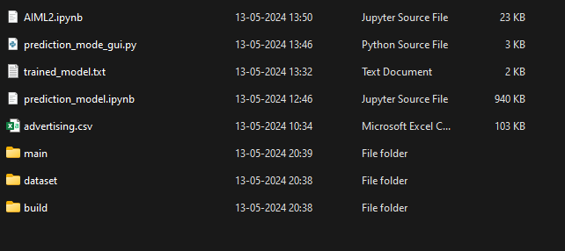

**Structure**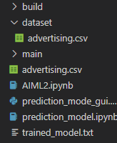

**4. Result:**

**4.1 Screenshots Of Output:**

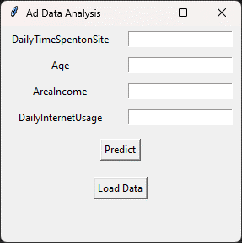

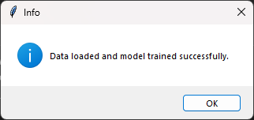

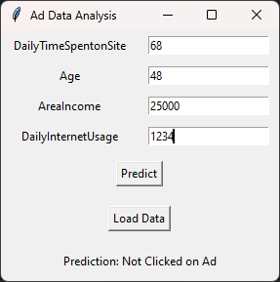

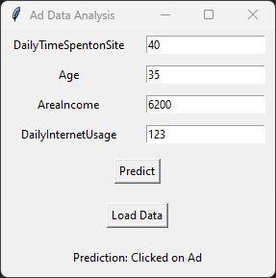

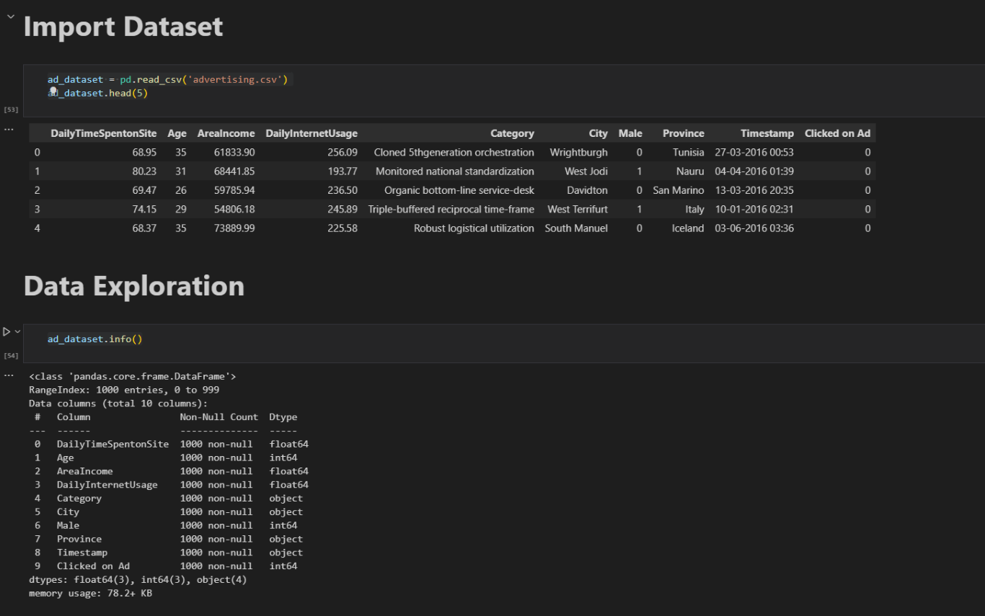**4.2 Screenshots Of Code:**

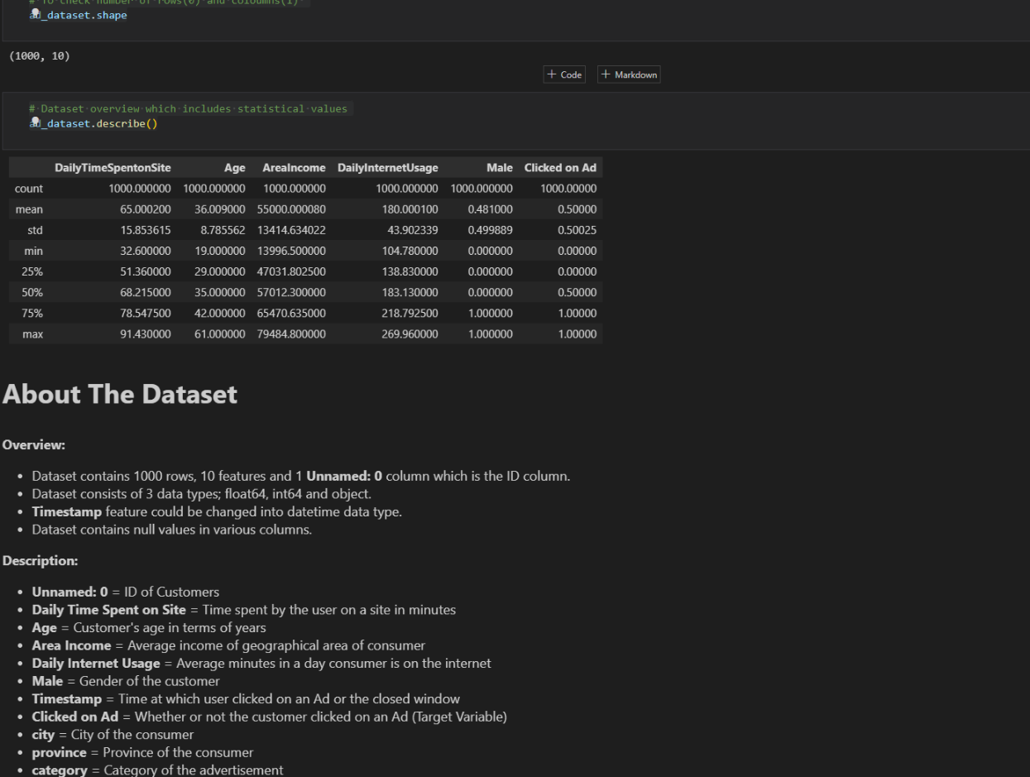

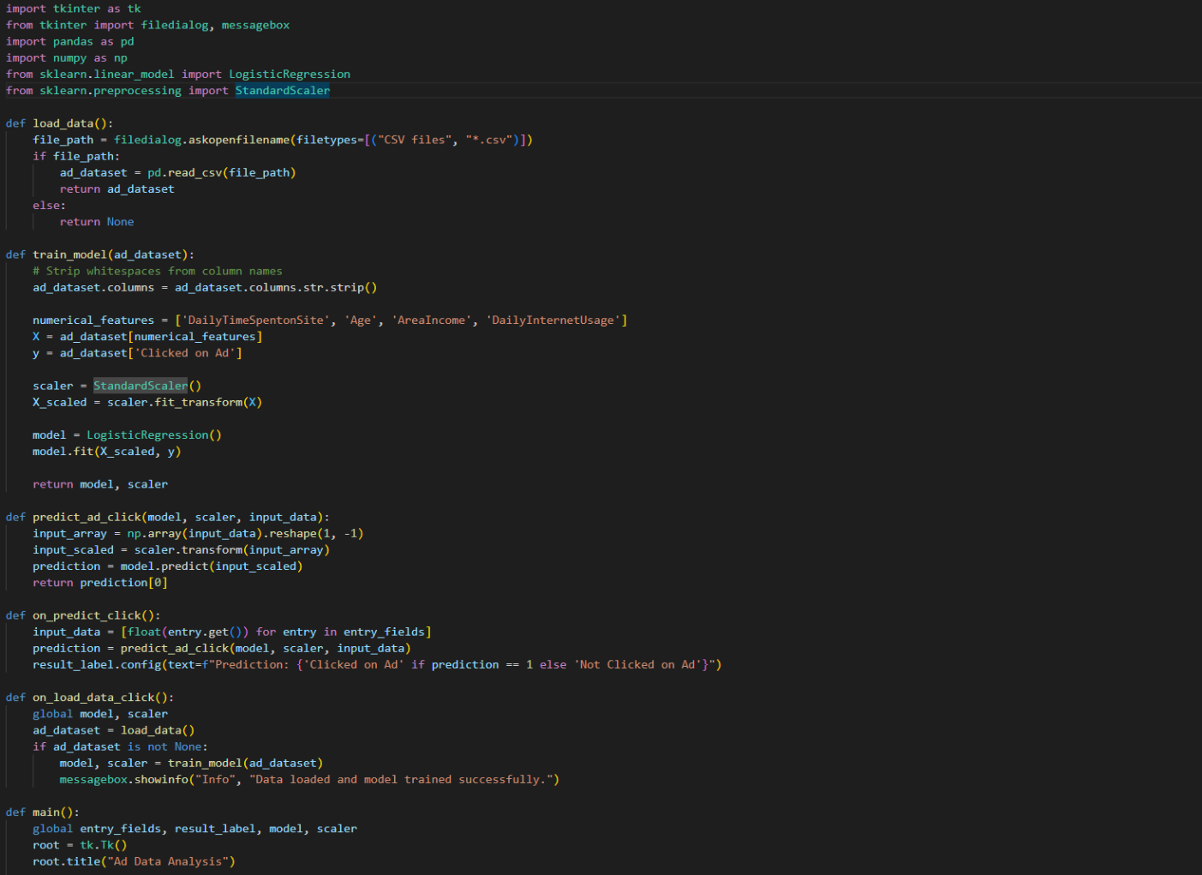

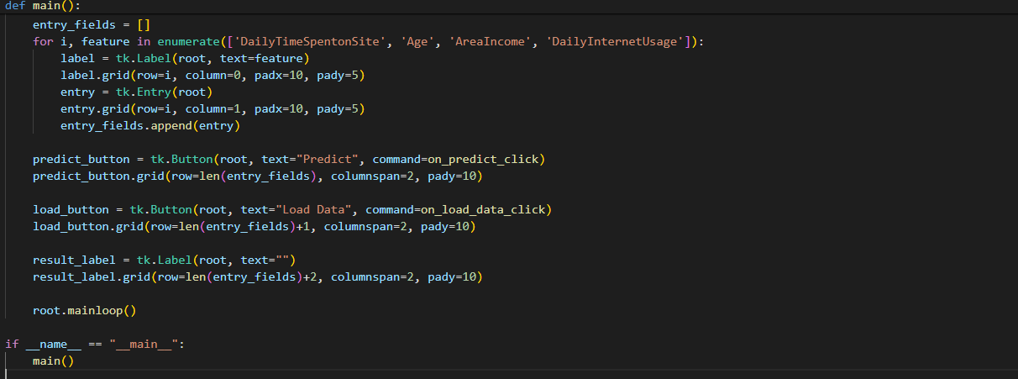

**5. References:**

* <www.javatpoint.com>
* [www.GeeksForGeeks.com](http://www.GeeksForGeeks.com)
* [www.youtube.com](http://www.youtube.com)